New Notes
A
- Add Skin and IV Therapy on the above TABS
- Remove Blog and replace with Our Story

B
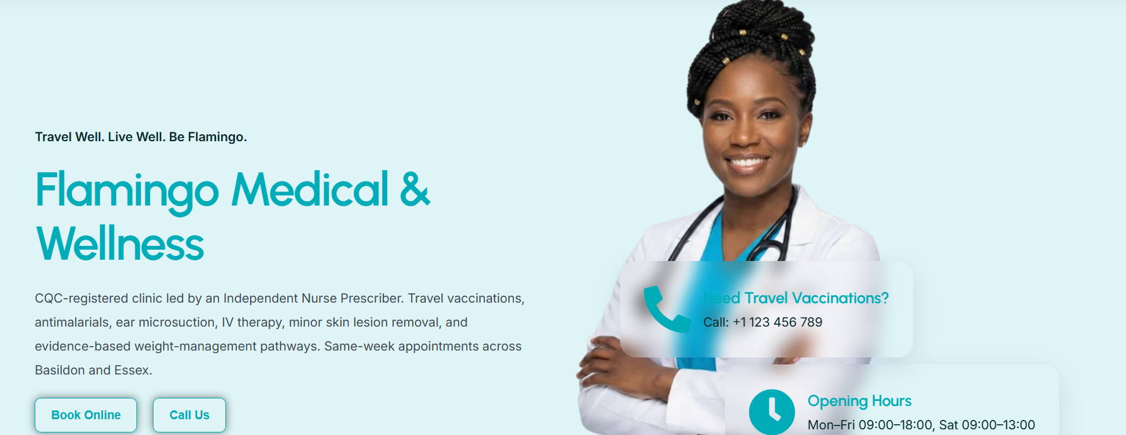
- Here, she wants pictures showing services sliding through as a carousel. She wants to start with outstanding and eye-catching photos such as
- Beautiful skin Male preferably WHITE – Similar to https://www.thebloomclinic.co.uk/treatments
- Beautiful Skin Female preferably WHITE OR INDIAN - Similar to https://www.thebloomclinic.co.uk/treatments
- People travelling to their holiday with suitcases
- Holiday Destination
- Weight Loss – use someone measuring their waste etc
- Ear Suction

Image sample



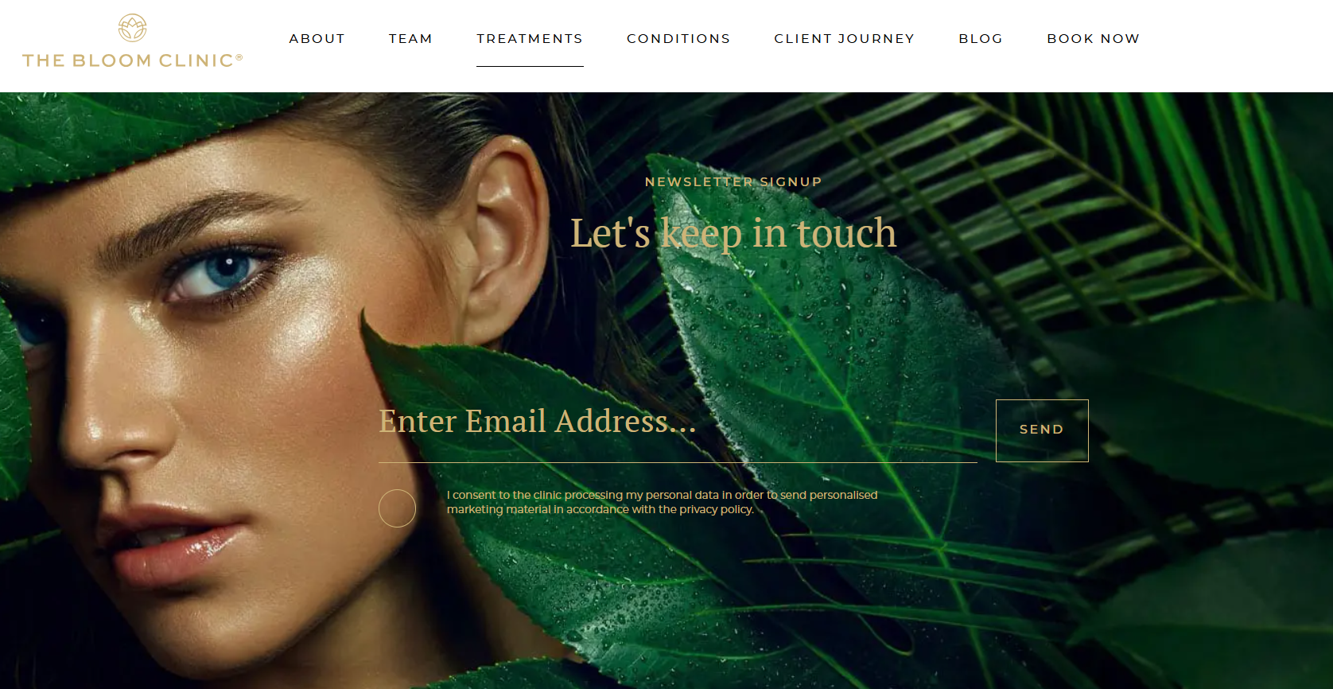

- Change Travel Well. Live Well. Be Flamingo to Private Clinical Care. Delivered with precision.

- See image and change the wording here to –

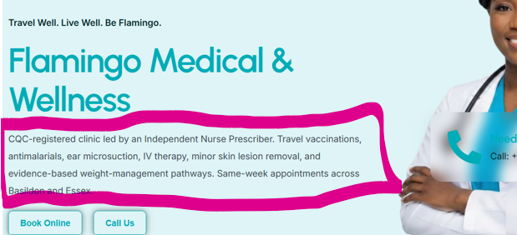
CQC-Registered Private Clinic led by an Advanced Nurse Practitioner & Independent Prescriber Led. Flamingo Medical & Wellness provides structured, evidence-based treatments within a discreet and professionally governed clinical setting.
Every appointment begins with assessment.
Every decision is clinically led.
Every patient receives individual attention.
Considered care.
Clinical standards.
Individualised treatment.

Book Online & What’s App Button
- Travel Health
Please see the changes requested

- https://travelhealthpro.org.uk/
- https://assets.publishing.service.gov.uk/media/6196386dd3bf7f054f43e02d/Greenbook-cover-Nov21.pdf

Travel Vaccination & Risk Assessment
Comprehensive destination-based risk assessment and immunisation delivered through a structured, clinician-led approach aligned with current Department of Health recommendations.
👉 Book Your Travel Consultation

Clinically Distinguished Travel Health
Most people plan their flights before they plan their health. Travelling may expose risks from food and water-borne infections to mosquito-transmitted diseases and country-specific entry requirements.
👉 Start Your Travel Consultation

Why Booking a Travel Consultation Early Matters?
Booking early gives you:
✔ Full protection before departure
✔ Enough time for multi-dose vaccines if needed
✔ Clear, stress-free preparation
👉 Book Now to Avoid Last-Minute Risk

What Is a Travel Risk Assessment?
A proper travel consultation is key. We take the time to understand your trip properly, using current Department of Health recommendations to guide every decision.
You’ll receive:
- A personalised risk assessment based on your destination and plans
- Clear advice on what you need and what you don’t
- Guidance on malaria prevention and travel health risks
- A structured vaccination plan if required

Who Should Book a Travel Consultation?
If you're travelling outside the UK, a consultation is strongly recommended.
We regularly support:

✈️ Frequent Travellers
Efficient, repeat-ready protection for business travel.

🎒 Backpackers & Adventurers
Rural exposure, long stays, and higher-risk environments.

👨‍👩‍👧 Families Travelling Abroad
Especially visiting friends and relatives — often higher exposure than standard holidays.

🌍 Volunteers & Aid Workers
Travelling to areas with limited healthcare access.

🧳 Last-Minute Travellers
Short notice? We can still provide effective protection and advice.
👉 Not sure if you need vaccines? Book a consultation and find out properly.

Common Travel Vaccines – What You Actually Need to Know
Following Department of Health guidance, we take a targeted approach:
- Yellow Fever: Often a single dose provides lifelong protection
- Hepatitis A: Long-term protection after full course
- Tetanus/Diphtheria/Polio: Many travellers already protected
- Typhoid: Requires boosters if ongoing risk
- Hepatitis B: Long-lasting after full vaccination
- Rabies / Japanese Encephalitis: Based on exposure, not routine
👉 Book a consultation to avoid unnecessary vaccines

Travel Health by Destination
Your risk depends on how and where you travel not just the country.

Africa
Yellow fever may be required. Malaria risk is common. Hepatitis A, typhoid, and meningitis may apply.

South Asia
Higher risk of food and water-borne infections such as typhoid and hepatitis A. Rabies and malaria may also be relevant.

Southeast Asia
Hepatitis A, typhoid, and sometimes rabies or Japanese encephalitis for rural or extended travel.

Middle East
Hepatitis A commonly advised. Meningitis ACWY required for Hajj and Umrah.

Central & South America
May involve hepatitis A, typhoid, and in some regions, yellow fever and malaria precautions.

Caribbean
Lower overall risk, but still requires individual assessment.

How It Works
A simple, structured process:
1. Book Your Consultation
Choose a convenient appointment time
2. Personalised Assessment
We review your travel plans and medical history
3. Clear Recommendations
Aligned with Department of Health guidance
4. Vaccination & Advice
Only what you need, nothing unnecessary
👉 Appointments available, including last-minute bookings

Travel Health Is More Than Vaccines
Vaccines are only one part of staying safe abroad.
We also guide you on:
- Malaria prevention
- Insect bite avoidance
- Food and water safety
- Managing medical conditions abroad
- What to do if you become unwell
We follow clinical judgement supported by Department of Health recommendations to ensure precision.
✔ Clinician-led consultations
✔ Evidence-based decisions
✔ No unnecessary vaccines
✔ Fast access, including urgent appointments
✔ Professional, calm, premium experience

Frequently Asked Questions

Do I need travel vaccinations for my trip?
Not always, and that’s exactly why a consultation matters.
Some travellers need several vaccines. Others may only need one, or none at all. It depends on your destination, length of stay, activities, and medical history.
We follow current Department of Health recommendations
👉 Book a consultation to find out exactly what you need

How far in advance should I book a travel consultation?
Ideally, 6–8 weeks before you travel.
This allows time for:
- Vaccines to become fully effective
- Multi-dose courses if required
However, if you’re travelling sooner, don’t assume it’s too late we can still provide effective consultation.
👉 Last-minute appointments are available

What happens during a travel consultation?
Your consultation is tailored to you
We take the time to review:
- Your destination and itinerary
- Duration and type of travel
- Your medical history
- Your previous vaccinations
You’ll receive clear, personalised advice aligned with Department of Health guidance.

Are travel vaccines mandatory?
Some are.
Certain countries require proof of specific vaccinations (for example, yellow fever) as a condition of entry.
Others are recommended based on risk rather than legal requirement.
We’ll clearly explain:
- What is required
- What is recommended
- What is optional
This will help you can make informed decisions before you travel.

Will I need multiple vaccines?
Not necessarily.
Many travellers assume they need several injections but in reality:
- Some vaccines provide long-term or lifetime protection
- You may already be covered from previous vaccinations
- Some trips require minimal or no vaccines

Do travel vaccines last for life?
Some do.
For example:
- Yellow fever is often a single lifetime dose
- Hepatitis A provides long-term protection after a full course
- Others, like typhoid, require periodic boosters
We review your history carefully so you don’t repeat vaccines unnecessarily.

Do you offer last-minute travel vaccinations?
Yes.
If you’ve left things late, we can still help.
While some vaccines need time to become fully effective, many can still provide meaningful protection even when given closer to your departure date.
We’ll prioritise what’s most important based on your travel plans.
👉 Contact us for urgent or same-week appointments

Do I need malaria tablets?
It depends on where you’re going.
Malaria risk varies significantly between countries and even within regions of the same country.
We assess:
- Your exact destination
- Length of stay
- Type of travel
And provide Department of Health-aligned advice on whether antimalarial medication is recommended.

Can you check if I’m already protected?
Yes, and this is an important part of what we do.
Many patients already have protection from:
- Childhood vaccinations
- Previous travel vaccines
Where appropriate, we can review your records or arrange testing to confirm immunity helping you avoid unnecessary vaccinations.

Is the yellow fever vaccine required for travel?
For some countries, yes.
Certain destinations require proof of yellow fever vaccination for entry, particularly in parts of Africa and South America.
The vaccine is only available at registered centres and is usually valid for life after a single dose.

Is a travel clinic better than going through the NHS?
NHS services provide core vaccines, but travel clinics offer:
- Broader vaccine availability
- Faster access to appointments
- More personalised travel risk assessments
- Specialist travel medicine advice
At Flamingo Medical & Wellness, we provide a comprehensive, clinician-led service aligned with Department of Health recommendations

What if I feel unwell after travelling?
If you develop symptoms such as:
- Fever
- Diarrhoea
- Rash
- Unusual fatigue
After travelling, you should seek medical advice and mention where you’ve been.
We can guide you on what to look out for before you travel, so you feel prepared.

How do I book a travel consultation?
Choose a convenient appointment time and receive personalised consultation, vaccination planning, and travel health guidance, all in one place.

